P R E S S I N F O R M A T I O N
10 Years German Center for Diabetes Research (DZD)
Working to Achieve Precise Treatment and Prevention Strategies for Diabetes
The DZD was founded ten years ago, on June 24, 2009, upon the initiative of the German Federal Ministry of Education and Research. More than 400 experts from various disciplines, including basic researchers, epidemiologists, health care researchers and clinicians, are working together to improve the prevention and treatment of diabetes and to avoid secondary diseases. One goal is to develop precise preventive and therapeutic measures; i.e. the right treatment for the right group of patients at the right time. Here the DZD has already reached the first important milestones.
The metabolic disease diabetes has many manifestations – not only type 1 diabetes, type 2 diabetes and gestational diabetes, but also subgroups of type 2 diabetes. With its work, the German Center for Diabetes Research contributes to identifying these subgroups and to developing targeted therapies for the respective subtype.
In addition to lifestyle and environmental factors, many different genes are responsible for the development of metabolic diseases such as type 2 diabetes and obesity. The DZD has succeeded in identifying more than 50 new genes associated with metabolism.
Genetic risk test for type 1 diabetes
Various genes are also involved in autoimmune type 1 diabetes. So far, about 50 disease-relevant loci are known, all of which seem to have an impact on the immune response. A risk model with selected genes enables better risk prediction for type 1 diabetes. By means of this genetic test, newborns with a 25-fold increased risk of type 1 diabetes compared to the general population can be detected. Families with a baby at high risk for the disease will be invited to participate in a prevention study to prevent the disease by oral insulin treatment.
Epigenetics – lifestyle is inheritable
Not only the genetic code itself influences the risk of diabetes. Lifestyle can also influence the extent to which certain genes are read and their information is implemented (epigenetics) – even over generations. The DZD also showed that diet-induced obesity and diabetes are transmitted epigenetically to the offspring, both via egg cells and via sperm. An epigenetic modification promotes obesity and fatty liver disease, both of which are related to type 2 diabetes.
Different clusters identified in type 2 diabetes
Type 2 diabetes is a disease that manifests itself very heterogeneously. There is not "the" type 2 diabetes, but rather different subtypes. Studies from Scandinavia show that there are different clusters with different degrees of severity. Three of these subtypes are associated with a high risk of consequential damage, while the other two are characterized by less severe disease progressions. The DZD was able to confirm these findings in 1,105 patients from the German Diabetes Study. In new studies, the DZD is now contributing to the development of therapies tailored to the individual subgroups in order to prevent or at least delay secondary diseases.
Different types of prediabetes
Evaluations of the DZD multicenter study "Prediabetes Lifestyle Intervention Study" show that already in prediabetes there are distinct subgroups that respond differently to lifestyle interventions. Not every prediabetic has the same high risk of developing diabetes later on. Rather, there is a high-risk group: test persons who suffer from fatty liver with insulin resistance or an insulin secretion disorder are very likely to develop a manifest diabetes disease. In addition, there is increased risk of developing secondary diseases later on. Studies indicate that intensive lifestyle intervention with a lot of exercise and long-term counseling can help to delay or even prevent the onset of the metabolic disease.
Polyagonists – a new therapeutic approach
DZD researchers are also working on new therapies to treat diabetes. Among other approaches, they have developed new drug candidates – polyagonists – for the treatment of type 2 diabetes and obesity. These polyagonists mimic the action of multiple hormones. In clinical studies, these drug candidates have proven to be extremely promising for the improved treatment of obesity and type 2 diabetes and are already in clinical phase 2 and 3 trials.
"Artificial" pancreas
In type 1 diabetes and in the advanced stage of type 2 diabetes, the insulin-producing beta cells in the pancreas are destroyed. The DZD is working on an artificial pancreas in which the beta cells are surrounded by a special Teflon membrane that allows hormones and nutrients to pass unhindered but prevents contact with the body's own immune cells. The great advantage of the system is that drugs to suppress the immune system can be dispensed with.
These examples demonstrate the DZD's successful translational diabetes research of recent years. DZD scientists are now also working with international scientists to develop specific therapies and prevention strategies for these different types of diabetes and for the various clusters of type 2 diabetes and prediabetes. In addition, innovative IT technologies, such as artificial intelligence, shall be used to identify further diabetes subgroups in order to be able to treat those affected by diabetes even more effectively in the future.

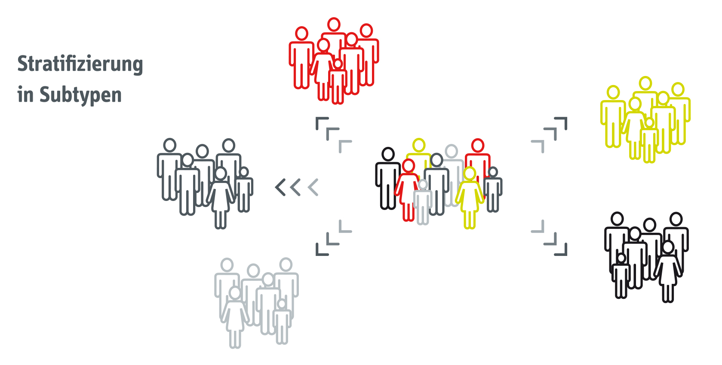
[[Grafik: Stratification of subtypes]]
Studies show that there are different clusters of type 2 diabetes and prediabetes. DZD experts are working on the stratification of subtypes and the development of precise prevention and therapy measures. Source: DZD
Media Contact:
Birgit Niesing
German Center for Diabetes Research (DZD)
Ingolstädter Landstraße 1
85764 Neuherberg
Germany
Phone: +49 (0)89-3187-3971
email: niesing@dzd-ev.de

